
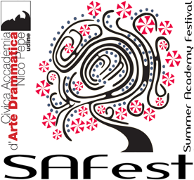

- Application form

- SAFest Summer Academy Festival 2024
- 16-20 July 2024

- Theme: "Il Fuoco della Passione" (The fire of Passion)

- Country :

- The Name of the company:

- University / Institution

- Play title :

- Director

- Author

- Duration
- The summary of the play should not exceed 5 lines!
- The summary in English

- Number of actors in the troop (maximum 10 students + 2 teachers) :

- the names of the participants in the play and teachers:
- N° | - Full Name | - Passport number | - Age | - Role in the play
- 1
- 2
- 3
- 4
- 5
- 6
- 7
- 8
- 9
- 10
- 11
- 12
- (If there are changes in the group please notify us at the earliest convenience)
- Full name of the person in charge for the company :
- Address :
- Personal Telephone
- Téléphone work
- E-mail
- Company information
- The Presentation and the Origin of the company
- (Example: year of creation - workshop emanating from an institution, professional director or amateur)

- Already played by the company? Yes No
- If the play was already performed; where and when?
- Number | - Places of representation | - Dates of representation

- Technical information:
- technical details | - Description:
- Dimensions (the scene and decorations):

- Assembling time

- Time of desinstallation
- Costumes :

- Accessories:

- Lighting plan :
- Wiring for sound:
- Do not forget to join to this application :
- Pictures of the proposed play (copyright free)
- Press review on the proposed play if available.
- Please send the application form to the following address :

- Deadline 30/04/ 2024

