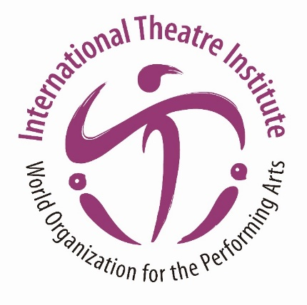
International Theatre Institute ITI
World Organization for the Performing Arts
Message for International Dance Day 2023 – 29 April
Author of the Message: YANG Liping, China
Dancer, Choreographer

English translation from the Chinese original
International Dance Day Message 2023 by YANG Liping

Dance—A Way to Communicate with the World

Body language is the humanity’s most instinctive form of communication. As new-born babies we can use our hands and feet to make dancing-like gestures even before we learned to utter a word, and then dance arises from this “primitive tongue.”

Many things prompt people to dance. In my hometown, my grandmother once told me that dance is a way to thank the Sun for bringing warmth and light to our lives.

When there is a good harvest, we would dance in the fields with joyous hearts to express our gratitude to the earth. When we meet someone we love, we may dance like a peacock spreading its tail feathers to win their affection. Even when we are sick, we may use mysterious dance rituals to repel the demons of sickness.

In my world, dance has been intricately interwoven into our lives and existence since earliest childhood. It has always been the key that unlocks human being’s communication with nature and all living beings. In my hometown, there is a saying: “If you have legs but cannot dance, you have wasted your life in vain”. Dance is closely connected to nature and life. As far as I’m concerned, dance is one and the same with nature and life—that is the true essence of dance.

Some people come to this world to carry on their lineage, some come to enjoy life, some come to seek experiences. For me, I am an observer of life. I come to see how a flower blooms and withers, how clouds float, and how dew condenses...

Therefore, all my creative inspiration comes from nature and life: the brightness of moonlight, the display of peacocks’ plumage, the transformation of a butterfly from a cocoon, the way a dragonfly skims the water’s surface, the way a caterpillar wriggles, the way ants form a queue...

Many years ago on a stage, I faced the audience and danced the first choreography I created—the peacock dance “The Soul of a Peacock”. Peacocks are still existing animals in the world. It is a creature that symbolizes sacrosanctity and represents beauty in the Eastern world because its appearance resembles that of the phoenix, with a reified posture comparable to the dragon. While dancing, I figured out the soul of the peacock.

The dance culture of mankind is bountiful, embracing common culture and attributes. We derive the essence of dance by observing nature, life, and all living beings that surround us. My nation, too, has an abundant dance culture that I passionately carry forward as an inheritance. It nourishes our mind and body, giving us the ability to communicate with the world. I collected some traditional primitive dances and brought them on stage, such as Yunnan Impression, Tibetan Riddle, Pingtan Impression and many more besides. All these dances originated from the land and were left to us by our ancestors as heritage, which needs our efforts to be preserved and introduced to the world.

Once these works were staged, people were deeply impressed by their captivating beauty and cultural significance. As a dancer, I have continued to explore the boundless realm of dance for decades and have been invited to create experimental contemporary works, such as Under Siege—The Full Story of Farewell My Concubine, and Rite of Spring for the global stage.

My art draws its inspiration from nature in my hometown, my personal life experiences, and the profound civilization of the East, which is an integral part of world civilization, as it provides diversity, richness, and above all, inspiration.

“Learning from nature” and “Unity of man and universe” is the philosophy, the wisdom, and the aesthetics of the East. These doctrines are also the spiritual core of my art. As human beings, we should respect nature, learn from nature, and harmonize with nature, just like the earth, the mountains, and the sky.

Dancers and choreographers need to listen more attentively to the joys and sorrows of the world, using dance to complete the dialogue we have had with nature, and life which has lasted for thousands of years.

Today, I will not only continue to share our dance culture with the world, but I also hope to invite all the dancers in the world who love dance and who would like to express their emotions through dance, to jointly dance for conveying our love and praise to heaven and earth.

Life never ends, and dance never stops.

Translated by GUO Yufeng, WANG Ling

