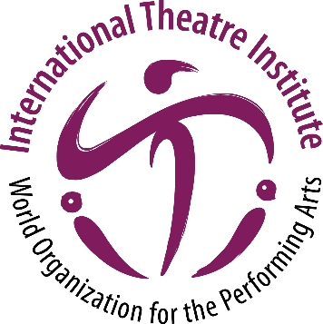
International Theatre Institute ITI
World Organization for the Performing Arts
Message for World Theatre Day 2022 – 27 March
Author of the Message: Peter SELLARS, USA
Theatre, Opera and Festival Director
English (original)
World Theatre Day Message 2022 by Peter SELLARS
Dear Friends,

As the world hangs by the hour and by the minute on a daily drip feed of news reportage, may I invite all of us, as creators, to enter our proper scope and sphere and perspective of epic time, epic change, epic awareness, epic reflection, and epic vision? We are living in an epic period in human history and the deep and consequential changes we are experiencing in human beings’ relations to themselves, to each other, and to nonhuman worlds are nearly beyond our abilities to grasp, to articulate, to speak of, and to express.

We are not living in the 24-hour news cycle, we are living at the edge of time. Newspapers and media are completely unequipped and unable to deal with what we are experiencing.

Where is the language, what are the moves, and what are the images that might allow us to comprehend the deep shifts and ruptures that we are experiencing? And how can we convey the content of our lives right now not as reportage but experience?

Theater is the artform of experience.

In a world overwhelmed by vast press campaigns, simulated experiences, ghastly prognostications, how can we reach beyond the endless repeating of numbers to experience the sanctity and infinity of a single life, a single ecosystem, a friendship, or the quality of light in a strange sky? Two years of COVID-19 have dimmed people’s senses, narrowed people’s lives, broken connections, and put us at a strange ground zero of human habitation.

What seeds need to be planted and replanted in these years, and what are the overgrown, invasive species that need to be fully and finally removed? So many people are on edge. So much violence is flaring, irrationally or unexpectedly. So many established systems have been revealed as structures of ongoing cruelty.

Where are our ceremonies of remembrance? What do we need to remember? What are the rituals that allow us at last to reimagine and begin to rehearse steps that we have never taken before?

The theater of epic vision, purpose, recovery, repair, and care needs new rituals. We don’t need to be entertained. We need to gather. We need to share space, and we need to cultivate shared space. We need protected spaces of deep listening and equality.

Theater is the creation on earth of the space of equality between humans, gods, plants, animals, raindrops, tears, and regeneration. The space of equality and deep listening is illuminated by hidden beauty, kept alive in a deep interaction of danger, equanimity, wisdom, action, and patience.

In The Flower Ornament Sutra, Buddha lists ten kinds of great patience in human life. One of the most powerful is called Patience in Perceiving All as Mirages. Theater has always presented the life of this world as resembling a mirage, enabling us to see through human illusion, delusion, blindness, and denial with liberating clarity and force.

We are so certain of what we are looking at and the way we are looking at it that we are unable to see and feel alternative realities, new possibilities, different approaches, invisible relationships, and timeless connections.

This is a time for deep refreshment of our minds, of our senses, of our imaginations, of our histories, and of our futures. This work cannot be done by isolated people working alone. This is work that we need to do together. Theater is the invitation to do this work together.

Thank you deeply for your work.

Peter Sellars

