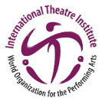
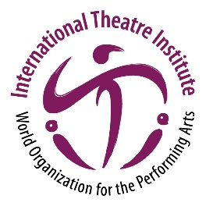
ITI/UNESCO Network for Higher Education in the Performing Arts
Network of UNESCO & ITI with Higher Education and Research Institutions

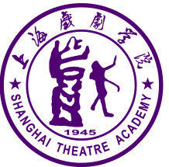
Traditional Performing Arts Event for Countries
that are Part of the Silk Road
(One Belt & One Road Initiative)
Event in Shanghai, 13 to 15 November 2019
A project of the Shanghai Theatre Academy,
in collaboration with the International Theatre Institute
Application Form
This application form has the following parts:
- General Information about the Institution and person applying for participation
- Information about possible Keynote
- Information about possible Performance
- Information about possible Workshop
Full information can be found in the attached documents
- Full information about the STA Event
- Open Call for the STA Event
If you have any question about the STA Event or the Application, please write to the Coordinator
Ms. LOU Yan, sta_network@163.com. Deadline: 28 September 2019

Application for the Traditional Performing Arts Event for Countries of the Silk Road (One Belt & One Road)
at STA, 13 to 15 November 2019, Shanghai, China
General Information
Full Name of the Applicant:
Institution:
Address of the Institution:
Country:
Job Title / Position:
Research Area:
Email: | Passport Number:
CV (less than 150 words):
Keynote Speech
Please inform if you would like to be a keynote speaker of the event.
□ Yes □ No
(If yes, please provide the following details.)
Title of your Speech:
Abstract (Brief introduction of your intended speech – max. 150 words):

Note: If you want to bring a team from your university to give a workshop and a student presentation, please fill in the following information as well.
Workshop
Name of the Workshop:
Theme of the Workshop:
Duration of the Workshop:
Description of the Workshop (max. 150 words):

CV of the workshop leader
(Skip this if the keynote speaker is the workshop leader)
Student Performance / Student Presentation
Name of the Performance:
Director:
Number of student performers on stage:
Total number of the group attending this event:

Performance Duration:
Performance Description (Maximal 150 words):

Language in which will be performed:
(It is necessary to provide full script/subtitles in English or Chinese later)
Video Link:
(You can also send your video by email together with this application form.)

Note: The performance will be presented in a venue similar to a black box theatre. Please make sure your performance requires no stage scenery and very simple lighting. The time for each group to do setup for light, sound and rehearsal should be no more than 1 hour.

CV of the leader of the performance (less than 150 words):
(Skip this if the keynote speaker is the leader of the performance)

The full application above must be completed and submitted before 28 September 2019
to LOU Yan (Coordinator from STA for this event) by email to sta_network@163.com.

