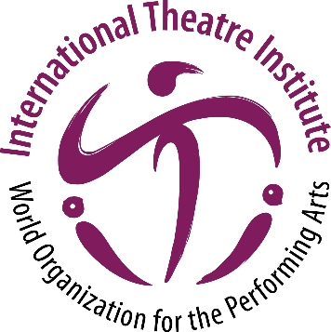
International Theatre Institute ITI
World Organization for the Performing Arts
World Theatre Day 2022 – 27 March
Biography of Peter SELLARS, USA
Opera, Theatre and Festival Director
English (original)
Peter SELLARS
Opera, Theatre and Festival Director
Peter Sellars, born in Pittsburgh, Pennsylvania (USA) is an opera, theatre and festival director who has gained international renown for his ground-breaking and transformative interpretations of classics, advocacy of 20th century and contemporary music, and collaborative projects with an extraordinary range of creative and performing artists. His work illuminates the power of art as a means of moral expression and social action.
He has staged operas at the Dutch National Opera, English National Opera, Festival d’Aix-en-Provence, Lyric Opera of Chicago, Opéra National de Paris and the Salzburg Festival, among others.
Sellars has collaborated on the creation of many works with composer John Adams, including Nixon in China, The Death of Klinghoffer, El Niño, Doctor Atomic, The Gospel According to the Other Mary and The Girls of the Golden West. Inspired by the compositions of Kaija Saariaho, he has guided the creation of productions of her work (L’Amour de loin, Adriana Mater, Only the Sound Remains) that have expanded the repertoire of modern opera.
Recent (pre-pandemic) projects include a new production of Doctor Atomic at the Santa Fe Opera, a staging of Claude Vivier’s Kopernikus for Festival D’Automne (Paris), and a production of Mozart’s Idomeneo for the Salzburg Festival.
Late in 2020 he conceived and directed “this body is so impermanent …” a film created in response to the global pandemic inspired by text from the Vimalakirti Sutra. Upcoming projects include a staging of the Roman du Fauvel in collaboration with musicologist and founder of the Sequentia Ensemble, Benjamin Bagby; a revival of Sellars’ acclaimed production of Tristan und Isolde, its story illuminated and deepened by the transcendent videography created by artist Bill Viola; and Perle Noire, meditations for Josephine, with music by composer and multi-instrumentalist Tyshawn Sorey performed by the incomparable vocalist Julia Bullock.
Sellars has led several major arts festivals, including the 1990 and 1993 Los Angeles Festivals and the 2002 Adelaide Arts Festival. In 2006 he was Artistic Director of New Crowned Hope, a festival in Vienna for which he invited emerging and established artists from diverse cultural backgrounds to create new work in the fields of music, theater, dance, film, the visual arts and architecture for the celebration of Mozart’s 250th birth anniversary. He served as the Music Director of the 2016 Ojai Music Festival.
Sellars is a Distinguished Professor in the Department of World Arts and Cultures at UCLA, the founding director of the Boethius Institute at UCLA, a resident curator of the Telluride Film Festival, and was a Mentor for the Rolex Arts Initiative. He is the recipient of a MacArthur Fellowship, the Erasmus Prize for contributions to European culture, the Gish Prize, and is a member of the American Academy of Arts and Sciences. He has been awarded the prestigious Polar Music Prize and been named Artist of the Year by Musical America.

