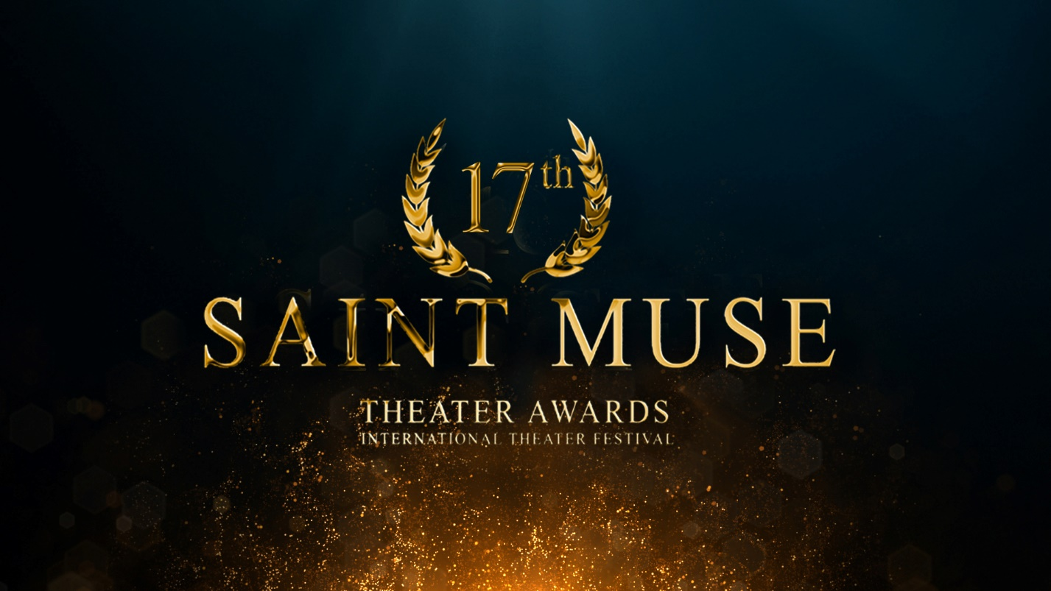

Application form for International Program 2023
Applications with Video are being accepted until 31 May 2023 at itimongolia.sma@gmail.com.

General Information
Name of the company
Full Address/County
Brief info on company
(not more than 300 words)

Person to contact
Briefly about the contact person
Full contact information
Website
FB page
Online link to Vimeo of the performance

Specific Information
Title of the production (Original and English) and credits
Duration of the production
(Intermission?)
Year of the premiere
Brief Description of the performance:
(Not more than 300 words)

Group Information
How many persons on tour?
(Actors, director, technicians and etc.)
Title | Full Name | Your recommendation of nomination | Date of Birth | Passport Number | Citizenship
Director
Actor(s)
Technician(s)

Technical Details
Dimension of your playing area | Minimum (width + depth + height)
 | Maximum (width + depth + height)
Requirement to the stage of performing area | Type (e.g. black box)
 | Floor
 | Max. Number of audience
Additional information | Number and dimensions of the required entries to the stage. Number of the required cloakrooms.
What technical equipment do you need?  (please give detailed and binding information) | light  (please name the plug type)
sound
(please name the plug type)
Electricity power source
(plug type?)
What technical equipment do you bring along? | Light  (please name the plug type)
 | Sound (plug type?)
Electricity power source
(plug type?)
Technical Specifics: | Pyrotechnics, fire, fog or something else?
Required time for set-up
Required time for set-down
Technical staff  How many technicians will come in the group to be present during the set-up? | Light technician
 | Sound technician
 | Stage technician
Technical staff  How many technician/assistants do you need from our staff? | Light technician
 | Sound technician
 | Stage technician

Appendixes

Please, attach to application following:

- Online link to Vimeo of the performance;
- Detailed technical rider (stage plan, light plan, sound equipment and etc) as separate attachments;
- Press cuts;
- High resolution only photos of the group members;
- High resolution only photos of the performance;
- Any other support material you think is relevant.

Please take into consideration that the organizers will negotiate technical support in some cases, as necessary.

Please also note that incomplete applications without appendixes will not be accepted and there will be no notifications about it.

The organizing committee will contact only if your performance is selected for the festival.

Application:
Please send your application form together with a link of the complete performance and a trailer on Vimeo and the all requested material before 31 May 2023. In case of having your performance not on Vimeo, please contact the organizers at itimongolia.sma@gmail.com and consult for submission using other means of file transfer.

Notification about the results: 7 June 2023

